

MINI PROJECT REPORT ON

**“AIR FLOW DETECTOR”**

SUBMITTED BY:

**K.SAI PRADEEP (1NH18EC056)**

Under the guidance of

**DR.K.C.R. NISHA**

**Professor, Dept. of ECE, NHCE, Bengaluru.**

**IN PARTIAL FULFILLMENT FOR THE AWARD OF THE DEGREE  
OF  
BACHELOR OF ENGINEERING**

**IN**

**ELECTRONICS AND COMMUNICATION**

## NEW HORIZON COLLEGE OF ENGINEERING

## DEPARTMENT OF ELECTRONICS AND COMMUNICATION ENGINEERING



**CERTIFICATE**

Certified that the mini project work entitled “**Air flow detector**” carried out by **K.SAI PRADEEP (1NH18EC056)** bonafide students of Electronics and Communication Department , New Horizon College of Engineering, Bangalore.

The mini project report has been approved as it satisfies the academic requirements in respect of mini project work prescribed for the said degree.

Project Guide HOD ECE

DR. K C R NISHA DR.SANJEEV SHARMA

**External Viva**

Name of Examiner Signature with Date

1.

2.

**ACKNOWLEDGEMENT**

The satisfaction that accompanies the successful completion of any task would be, but impossible without the mention of the people who made it possible, whose constant guidance and encouragement helped us succeed.

We thank **Dr. Mohan Manghnani**, Chairman of **New Horizon Educational Institution**, for providing necessary infrastructure and creating good environment.

We also record here the constant encouragement and facilities extended to us by **Dr.Manjunatha**, Principal, NHCE and **Dr. Sanjeev Sharma**, Head of the Department of Electronics and Communication Engineering. We extend sincere gratitude to them.

We sincerely acknowledge the encouragement, timely help and guidance to us by our beloved guide **Dr. K C R Nisha** to complete the project within stipulated time successfully.

Finally, a note of thanks to the teaching and non-teaching staff of electronics and communication department for their co-operation extended to us, who helped us directly or indirectly in this successful completion of mini project.

**K. HARSHA VARDHAN (1NH18EC043)**

**TABLE OF CONTENTS**

ABSTRACT

**CHAPTER 1**

INTRODUCTION…………………………………………………………………………………6

**CHAPTER 2**

LITERATURE SURVEY…………………………………………………………………………8

**CHAPTER 3**

PROPOSED METHODOLOGY………………………………………………………………….9

**CHAPTER 4**

PROJECT DESCRIPTION ………………………………………………………………………..10

4.1 HARDWARE DESCRIPTION……………………………………………………………….

4.2 SOFTWARE DESCRIPTION…………………………………………………………………

**CHAPTER 5**

RESULTS AND DISCUSSION…………………………………………………………………18

**CHAPTER 6**

CONCLUSION AND FUTURE SCOPE …………………………………………………………20

REFERENCES…………………………………………………………………………………….20

**ABSTRACT**

Air flow detector is essential in many applications where it is necessary to detect the air flow presence. This air flow detector is used to reduce the overheating of devices. It is also used to check whether there is air flow in a given space. In this project, the circuit is designed by using IC LM358(op amp), IC 7805 (voltage regulator),filament of the bulb (RTD), POT(100k), DC supply of 12 volts, capacitors . when we apply 12v dc supply , variation of voltage occurs across the filament due to air flow and this variation is taken by the op amp, where opamp is a comparator, here we fix the reference voltage by adjusting the POT (variable resistor). This opamp compare the reference voltage and the voltage across the filament, it gives the output voltage only when the voltage from the filament is greater than the reference voltage. When air is present then LED glows, if not LED doesn’t glow.

**CHAPTER 1**

**INTRODUCTION**

Air flow detector is used to detect the flow of air, it is used in many applications as it provides a visual indication of the air at which the air is flowing. It is used to detect the air flow or presence of air where ever we need. Because it gives a clear picture of air present in a given space. For example, we use it mostly in car engines to estimate the air flow with in it, so that we come to know how much fuel is needed for proper functioning of engine.

This circuit is assembled utilizing LM358 IC. This circuit is a simple detection of air flow, this circuit can be signalized in case of air flow. The filament of a glowing bulb is the detecting part of the circuit. The filament L1 can be made by expelling the glass o f a 4 0 W glowing bulb. These sensors will experience the changes in heat whenever it exposed to the air flow. when there is no air flow the resistance of the filament will be low. When there is air flow, the resistance drops, because the moving air flowing through the filament reduces the heat in the filament. This variation in the resistance will deliver variation in the voltage over the filament. These varieties will be grabbed by the operation amp (LM358). LM358 is a comparator IC with four inbuilt comparators. A comparator is a simple circuit that moves signals between the analog and digital universes. It takes two input voltages and gives output to pick the bigger one. The two input pins are named as inverting (V-) and non-inverting (V+). The output goes high when voltage at V+ is more prominent than that at V-, and vice versa. In many applications, one of the pins is given a reference voltage and the other one gets the voltage from the filament (analog signal). If the inverting pin (V-) is set as reference, at that point V+ must results this reference to bring about high output. For inverted logic, the reference is set at V+ pin. The brightness of the LED at its output will be shifted relatively to the air flow.

It can be used as temperature detector in various applications, we need it to check the transfer of amount of contamination using chemical media like air, we need to ensure that the device not to get overheated. it is mostly used in industries which gives a safety option for our devices to get damaged. (Caution: Do not touch the filament of the bulb by hands. this circuit is given by 12 v DC power supply).

**CHAPTER 2**

**Literature survey**

* In 2014 int forum Allergy rhinol explained the psychological mechanism for sensing a nasal airflow.

Nasal impediment is a typical otolaryngologic protest, yet the component of detecting wind stream isn't generally comprehended. The goal of this work was to survey current information on the physiological component for detecting nasal wind stream.

Understanding the physiological instrument of how the nose detects wind stream can help in diagnosing the reason behind quiet indications, which enables doctors to give better treatment choices to patients.

* DR F Emerson soloman (Assistant professor), J Evangeline Cicelia (Department pf Bio Medical Engineering) Bharath University, Chennai.

Hence the circuit can give a visual sign of the pace of Air flow. This gadget can likewise be utilized to check regardless of whether there is air flow in a given space. The filament of glowing bulb is the detecting some part of the filament. When there is no air flow the resistance of the filament will be high. Therefore the Air flow is identified, as a output the LED shows.

* AKM Arifuzzman, Electrical and Computer Engineering ,The University of Albama at Birmingham, USA .

They have built up a low-power Thermal based Air flow sensor for low Air flow biomedical applications. The proposed sensor circuit includes a detecting Current mirror circuit, a Air flow controlled ring oscillator, a CMOS inverter-based level shifter amplifier, and a driver circuit. The sensor is associated with the detecting mirror circuit. The ring oscillator is associated with the mirror circuit and is worked with a three-stage inverter to make frequency variation with air flow. The output of the ring oscillator is intensified by a level shifter amplifier, and at last, the driver circuit sends the output sign to the observing gadget. The complete power scattering of this sensor circuit is low.

**CHAPTER 3**

**PROPOSED METHODOLOGY**

* **Phase 1:** Literature survey is done to select the experiment.
* **Phase 2**: Mini project was finalized as air flow detector by us.
* **Phase 3:** Components for making the working model were purchased from the market.
* **Phase 4:** Preparation of the working model.
* **Phase 5:** The connections were according to the circuit given below**.**
* **Phase 6**: Working on presentation**.**
* **Phase 7:** Report making
* **Phase 8:**Finally prototype is ready along with the report.

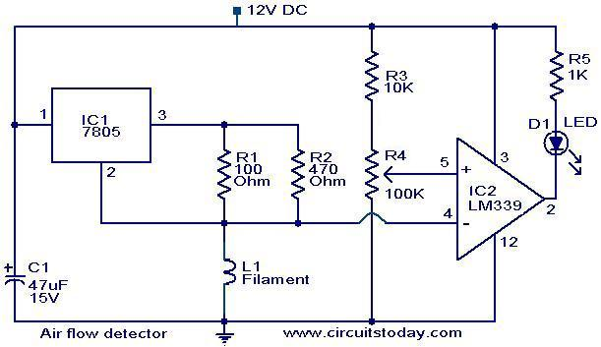

Figure 3.1 : circuit design of the air flow detector

**CHAPTER 4**

**PROJECT DESCRIPTION**

The main aim of the project is to detect the air flow. The air flow is indicated by the LED’s. It is very usefull to prevent the damage of the equipment .

**COMPONENTS REQUIRED**

* OP AMP (IC LM 358)
* VOLTAGE REGULATOR IC(7805)
* 40W INCANDESCENT BULB FILAMENT
* LED
* 12V DC SUPPLY
* RESISTORS- (100,680,330,10K)
* BREADBOARD
* CAPACITORS-(100µF)

**OP AMP (LM 358) –**

It consists of two independent, high gain OPAMPS in a single package. An important feature of this IC is that we don’t need any independent power supply for the working of each comparator for a wide range of power supply. It is also used as a transducer amplifier, DC gain block etc. it has a large DC voltage gain of 100 dB.

**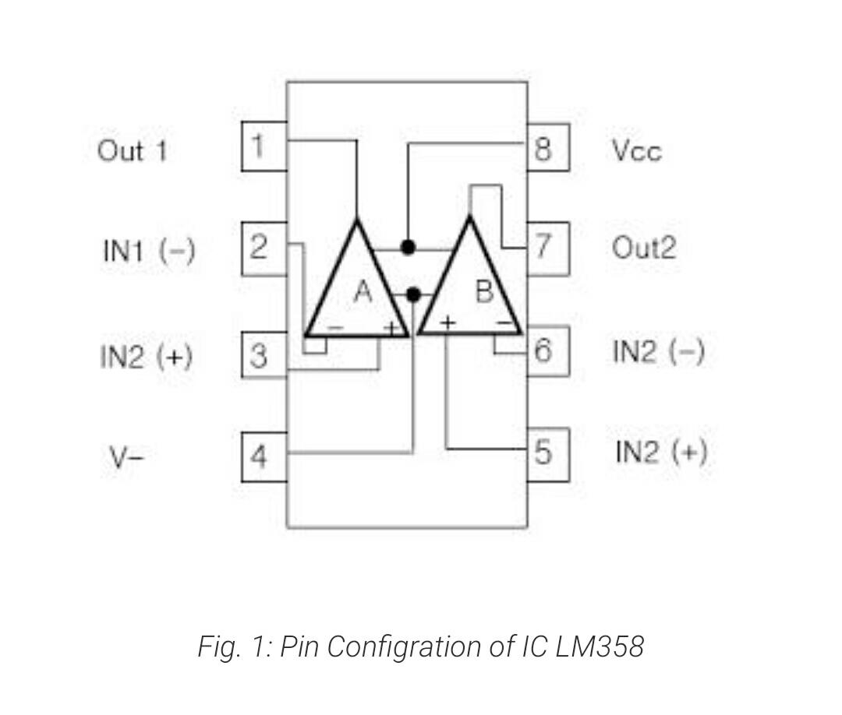**

It indicates 8-pin integrated circuit. it generally used as amplifiers ,high pass filters ,low band pass filters in very low frequency ,analog adders and it can be act as buffer with a gain of 1.

One of the advantages of it is to operate at a single DC power supply ranging from 3V to 32V, even we can set it to 5V to 15V by some difficulties.

In fact, circuit designed in such a way that it need two power supplies, one positive and one is negative, but it can only be connected to the positive power supply while the negative power supply is replaced by the ground. However, depending on us we need to use that negative power supply.

In this circuit, this OP –AMP is acting as comparator op amp and picks the voltage from the filament and compare it with reference voltage and gives the output only when the filament voltage is higher than reference voltage .

**VOLTAGE REGULATOR (IC 7805)-**

Voltage sources in a circuit does not give a constant voltage as an output. There will be some fluctuations in the resulting output. Then this voltage regulator maintains the constant voltage value. The IC 7805, a member of 78xx series of fixed linear voltage regulators used to maintain such voltage fluctuations. The xx in the 78xx indicates what value of the voltage it maintains constantly. The 7805 IC provides a constant supply of 5 volts.

We have noticed that there is a large difference between input voltage and output voltage of the voltage regulator. These difference between input and output voltages is released in the form of heat. Greater the difference, greater the heat dissipated so that the regulator may get destroyed or malfunctioned so it is better to give input 2 or 3 voltage more than the output voltage so now we have 2 options. One is to design the circuit such that the circuit limits the voltage 2-3 voltage above the output regulated voltage, second is to maintain a appropriate heat sink.

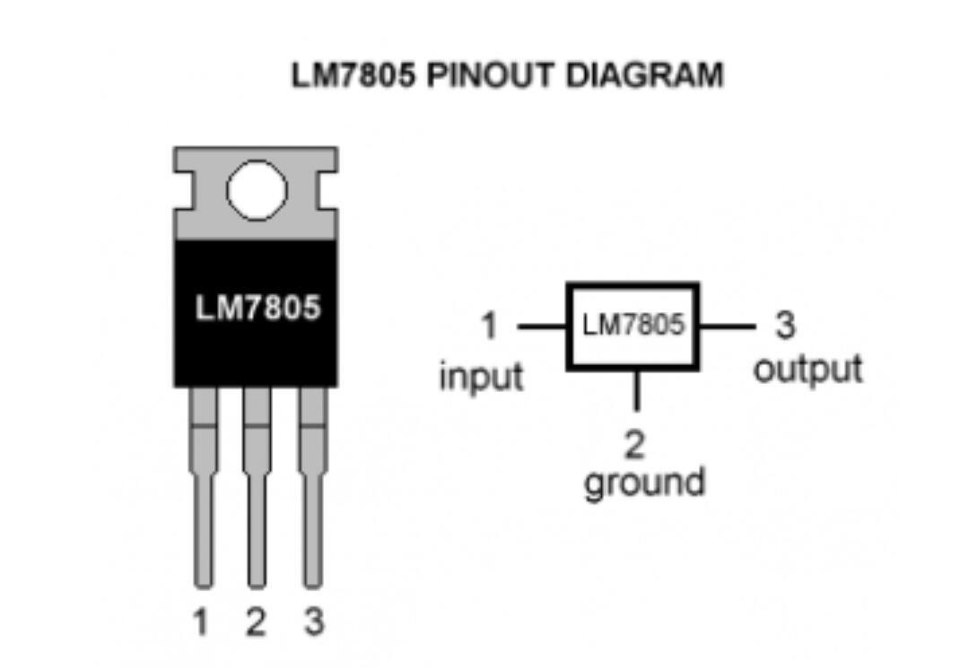

Figure 4.2: pin diagram for Ic7805

IC7805 is not very efficient and has voltage drop issues lot of energy is wasted in the form of heat. So, it is better to use a heat sink by calculating it is size properly.

**FORMULA: (input voltage -5)\* output curre**nt

Voltage regulator LM3805 maintain constant voltage from the variation in the voltage at the filament.

**INCANDESCENT BULB FILAMENT –**

Here the component to be used originally was RTD (resistance temperature detector). But to cut the cost and make a pocket-friendly model, we use an incandescent bulb filament in the place of RTD.

It is used to replace the working of RTD in order to detect the air flow. The filament here acts as a resistor.

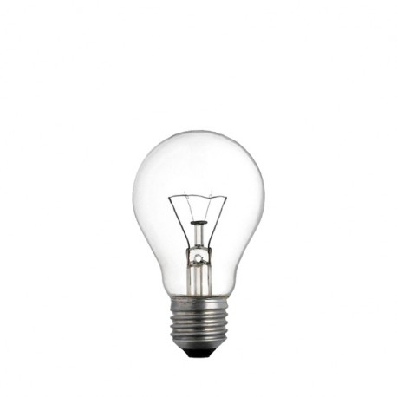

Figure 4.3: Incandescent bulb filament

Filament is protected from oxidation with a glass that is filled with inert gas or a vacuum. In a halogen lamp, filament evaporation is slowed by a chemical process that redeposit metal on the filament extending its life. These are manufactured in a wide range of sizes, light output and voltage ratings from 1.5v to about 300 volts.It require no external regulating equipment, having low manufacturing costs , and work equally well on either alternating current or direct current. It require no external regulating equipment, having low manufacturing costs, and work equally well on either alternating current or direct current. As a result these are used widely in everywhere like house holding and commercial lighting, for portable lighting such as table lamps, cars headlamps and flash lights decorative, advertising lightings.

When the heat is more in the filament, then resistance is more, then doesn’t glow which means that air flow is not there .similarly when air flow is there, then heat in the filament decreased ,resistances also decreased ,then LED glows,

**LED-**

A light emitting diode (LED) is a two lead semiconductor light source that works the same as a basic p-n junction diode, only difference being that the LED emits light too. When the voltage at the anode of the LED is more positive than the voltage at the cathode lead by at least the forward voltage drop of the LED, the current starts flowing through the LED and the LED lights up. This effect by which the LED lights up is called as the electroluminescence and the color of the LED is determined by the energy gap of the semiconductor.

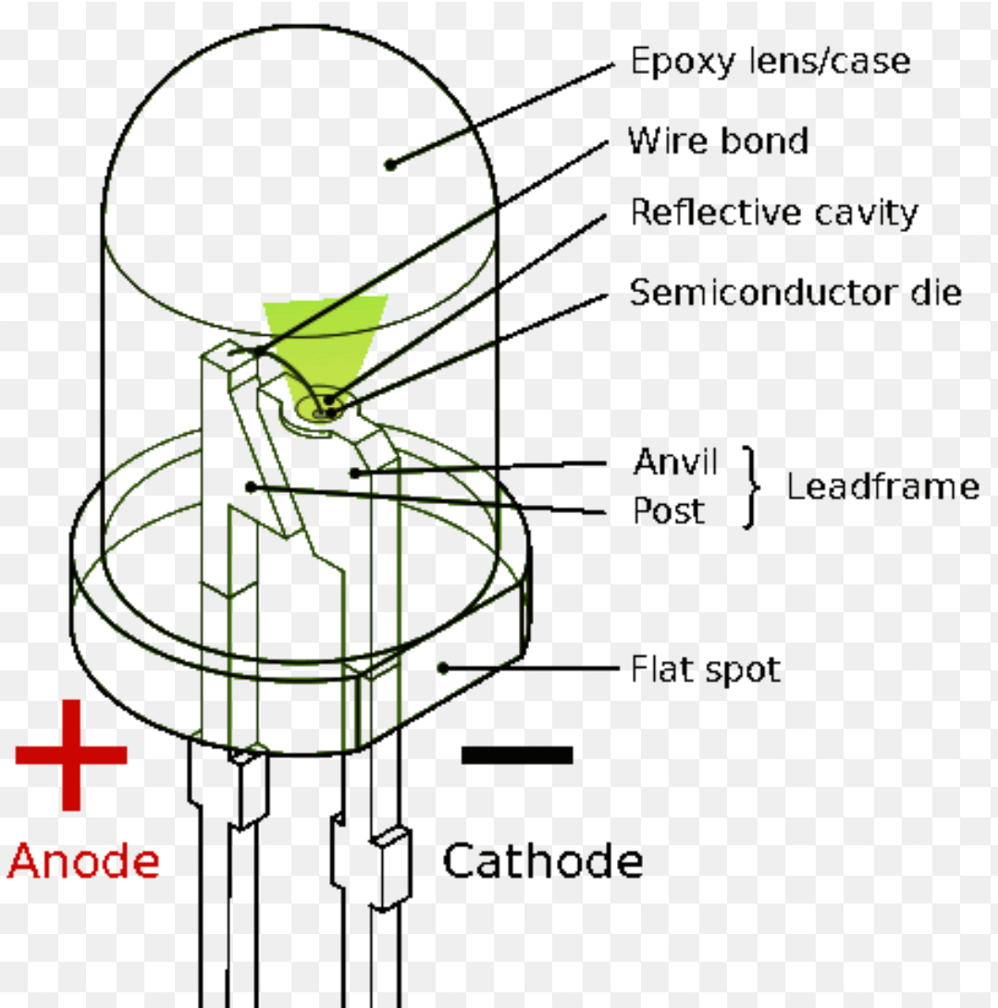

Figure 4.4: LED internal structure

**BREADBOARD-**

A breadboard consists of many tiny sockets interconnected with each other in a particular fashion. A breadboard acts a base for the connections of electronic components in our circuit which works just by inserting jumping wires and the components directly and according to the interconnections.

This also reduces the required area for the circuit, the required components for the preparation of the circuit and thus reducing the budget of the project making it more pocket friendly when compared to other circuit bases.

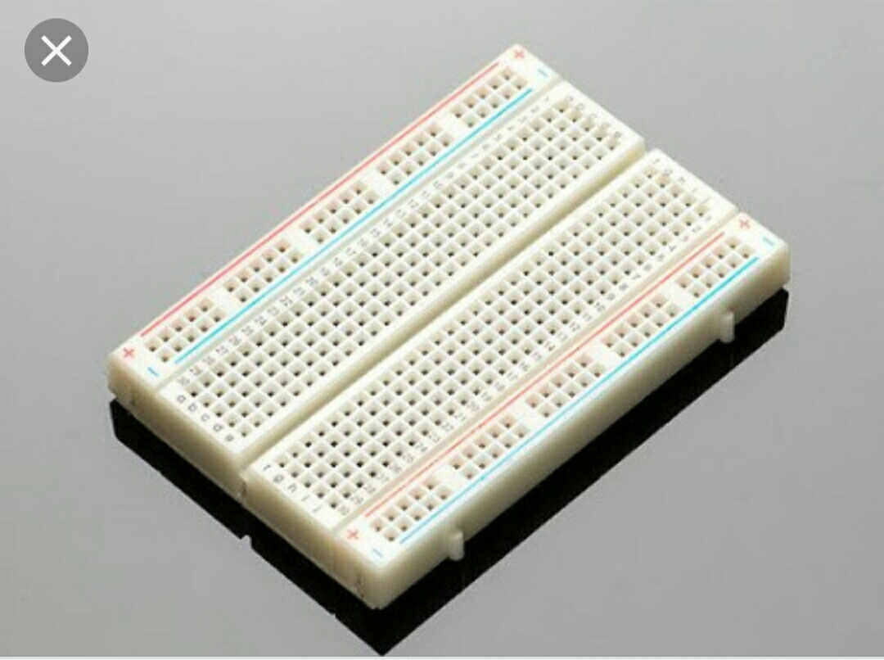

Figure 4.5: Bread board

**RESISTORS-**

Resistor is a passive 2 terminal electrical component that implements electrical resistance as a circuit element.in electronic circuits resistors are used to reduce the current flow adjust signal levels to divide voltages ,bias active elements and terminate transition lines, among other uses .high power resistors that can dissipate many watts of electric power as heat may be used as part of motor controls in power distribution systems. fixed resistors have resistances that only changes slightly with temperature, time or operating voltage. variable resistors are used to adjust the circuit elements, devices for heat, light, humidity, many more.

**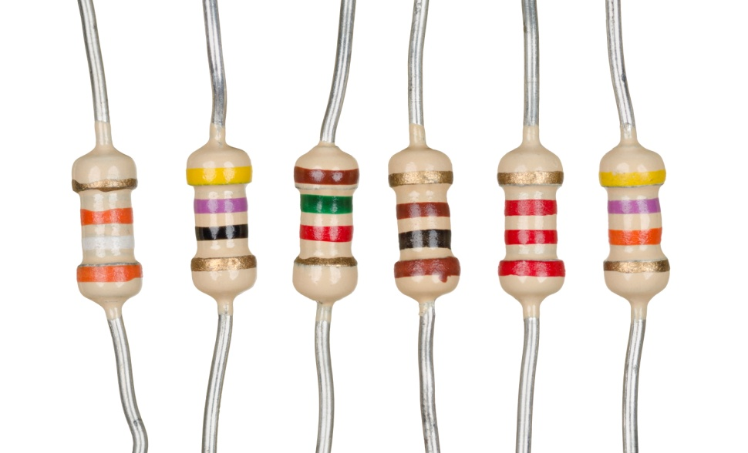**

[Figure 4.6: Resistors](https://www.google.com/url?sa=i&source=images&cd=&ved=2ahUKEwj70-TmgOzlAhXGPI8KHXfQDjoQjRx6BAgBEAQ&url=https%3A%2F%2Fen.wikipedia.org%2Fwiki%2FResistor&psig=AOvVaw07Iq4KBz9yjdBffofulHvv&ust=1573900070990411" \t "_blank)

**CAPACITORS-**

Capacitors are used to store electric charge, consisting of a one or pair of conductors separated by an insulator. Its function is to store electric energy and give it to the circuit when the circuit need. It charges and discharge the electric charge stored in it.it blocks DC and allows only AC flow.

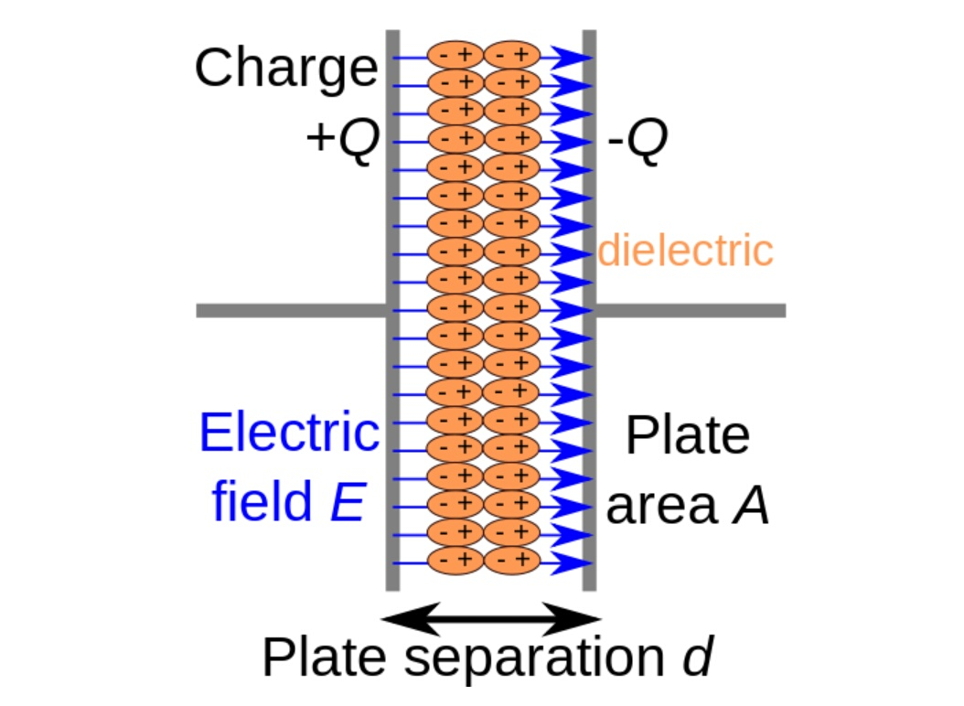

Figure 4.7: internal functioning of capacitors

The capacitors were originally known as condenser or compensators. The physical form and construction of practical capacitors vary widely. Most capacitors contain at least two electrical conductors in the form of a metallic plate or surfaces separated by di-electric medium. A conductor may be a foil, thin film, sintered bead of metal or an electrolyte. The non-conducting di-electric increases the capacitors charge capacity. Commonly used materials has di-electrics includes glass ceramic plastic film, paper, mica, air and oxide layers .These are widely used as in various parts of electric circuits to charge or discharge electric current. Unlike an ideal resistor capacitor doesn’t dissipate energy. When a voltage is applied across two terminals of capacitors a electric field is developed between the capacity plates, causing negative charge to deposit on one plate and negative thoughts on the other plate of a capacitor.

**POWERSUPPLY-** A power supply is a device that supplies electric power to the electric load. the term is most commonly referred to electric power that converts one form of electrical energy to another form though it may also refer to that converts another of energy (mechanical ,chemical , solar) to electrical energy. The regulated power supply is that controls the output voltage or current to a specific value; the controlled value is held nearly. All power supplies having a input connections , which receives energy in the current from different sources, then there will be one or more outputs to deliver current to the load ,such as electrical outlet, energy storage devices such as batteries or fuel cells, generators or alternators ,solar power convertors , or another power supply.

The input and output are connected through wires, but now a days we use wireless energy transfer to supply current through the load. And we have some input and output as well, for functions like as external monitoring and control.

[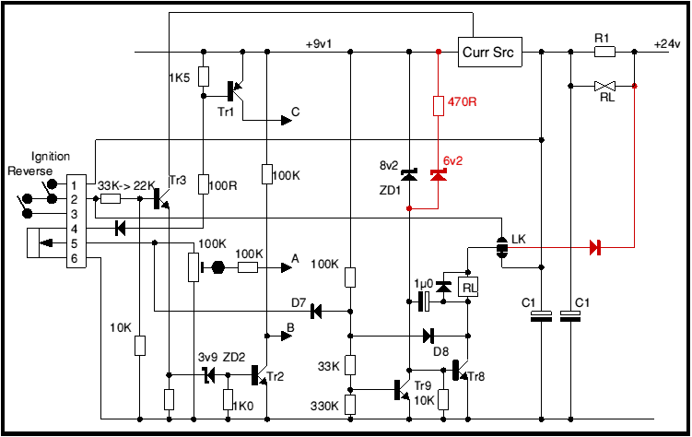](https://www.google.com/url?sa=i&source=images&cd=&ved=2ahUKEwj33tqciuzlAhWBNo8KHdUVDEMQjRx6BAgBEAQ&url=https%3A%2F%2Fwww.4qd.co.uk%2Fdocs%2Finternal-power-supply-and-protection-circuitry%2F&psig=AOvVaw2sYsgKXZ5bJtE-321QmN50&ust=1573902587240073" \t "_blank)

Figure 4.8 : Internal structure of power supply

**PRINCIPLE**

* Variation of resistance with temperature.
* Air as an insulator, when currents through a resistor(filament), it gets heated up. Now air is made to flow through the resistor of the bulb then the resistor cools down. We know that resistance is directly proportional to heat. Thus, resistor starts decreases its resistance along with the voltage drop in the circuit and current starts flowing through the bulb.

**WORKING**

The filament of a incandescent bulb is the sensing part of the circuit.

When there is no air flow the resistance of the filament will below. When there is air flow the resistance drops, because the moving air will remove some of the heat generated in the filament. This variations in the resistance in the resistance will produce variations of voltage across the filament. These variations will be picked up by the OPAMP (LM339) and the brightness of the LED at its output will be varied proportionally to the air flow.

But we are using LM359which is inverting OP AMP

**CHAPTER 5**

**RESULTS AND DISCUSSION**

We rig up the circuit using all the components as we mentioned above. When we applied the biasing voltage.

* We applied 9volts, then voltage source is producing a sound which indicates that circuit is shorted somewhere.
* But it is not the problem, opamp what we used works as a difference amplifier only at 12 volts.
* Then we applied 12 volts, then we are getting the output but in a reverse manner.
* Actually, we are using a box to create a vacuum space.
* We kept the bulb in the box
* When we apply voltage, filament in the bulb act as resistor and get heated up due to flow of current in the filament.
* When we keep the box close, then vacuum is created. Then filament is been heated .since there is no air, heat in the filament will be increased.
* We know that heat is directly proportional to resistance.
* Due to high resistance value, the voltage coming at the input of the opamp is very low which is less than the reference voltage set by the opamp.
* Then led doesn’t glow due to high resistance value in filament and very low current flows through led.
* It means the air flow is not detected.
* Now when we keep the box open then, the air in the surroundings made the filament cool.
* Resistance value decreases
* The sufficient voltage is gone at the input of the opamp which is greater than the reference voltage.
* The current flows the led and the led glows.
* It means that air flow is detected



Figure 5.1: when there is air flow

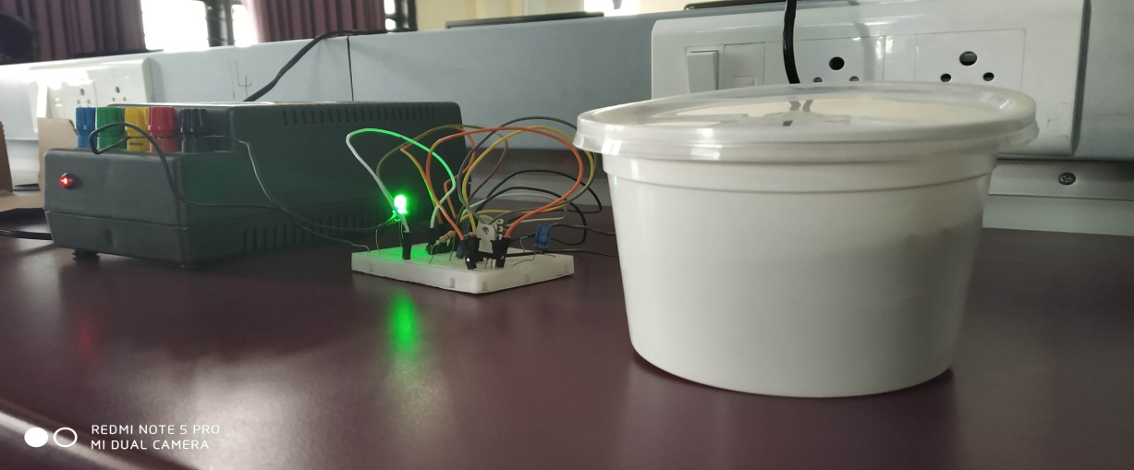

Figure 5.2: When there is no air flow

**CHAPTER 6**

**CONCLUSION AND FUTURE SCOPE**

When we apply DC voltage of 12 volts, then the voltage from the filament is picked by the OP AMP and compared with the reference voltage and give the output by glowing the LED, varying with the air flow. when the air flow is there, then LED will glow .and air flow is not present then LED is not glow.

**ADVANTAGES**

* In high power density electronic devices this air flow detector is useful for indication purposes to get rid of damages.
* It is used to flow of air in areas like car engine, where it is required to estimate the amount of fuel needed by the engine.
* It is used in chemical industries for better ventilation system.
* It is used in mechanic shop to detect the air present in rubber tube.

**DISADVANTAGES:**

* Since Zener diode is being used, the efficiency of the circuit is affected. This is because loss in series resistor causes a decline in efficiency in case of heavy loads.
* The resistance temperature detector is expensive and it is easily affected by shock and vibration.

**REFERENCES**

# 1.Khanaa, V., Thooyamani, K.P., Udayakumar, R., Information sharing time based controlled system in emergency situations, Middle - East Journal of Scientific Research, V-18, I-12, PP-1845-1850, 2013

**2**.Kumar, J.R., Vikram, C.J., Naveenchandran, P., Investigation for the performance and emission test using citronella oil in single cylinder diesel engine, Middle - East Journal of Scientific Research, V-12, I-12, PP-1754-1757, 2012

**3**.Manavalan, S., Golden RenjithNimal, R.J., Efficient and evaluation properties of medicinal products and flowering plant conventional diesel, International Journal of Pure and Applied Mathematics, V-116, I-19 Special Issue, PP-407-411, 2017

**4.**Manavalan, S., Jose Ananth Vino, V., Extraction and optimization of Biodiesel from neem oil, International Journal of Pure and Applied Mathematics, V-116, I-19 Special Issue, PP-401-404, 2017

**5.**Manavalan, S., Jose Ananth Vino, V., Extraction and optimization of Biodiesel from neem oil, International Journal of Pure and Applied Mathematics, V-116, I-19 Special Issue, PP-401-404, 2017

**Appendix:**

**Resistor**

There are various sorts of resistors accessible in the market with different rating and sizes. A portion of these are portrayed beneath.

* Wire wound resistors.
* Metal film resistors.
* Thick film and Dainty film resistors.
* System and Surface Mount Resistors.
* Variable Resistors.
* Unique resistors.
* Wire wound Resistors

These resistors differ in physical appearance and size. These wire-wound resistors are normally a length of wires typically made of an amalgam, for example, nickel chromium or copper-nickel manganese composite. These resistors are the most established kind of resistors having phenomenal properties like high power evaluations and low resistive qualities. During their utilization, these resistors can turn out to be exceptionally hot, and therefore these are housed in a finned metal case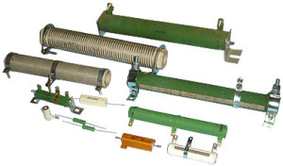

* **Metal film resistor**

These resistors are produced using metal oxide or little bars of clay covered metal. These are like carbon-film resistors and their resistivity is constrained by the thickness of the covering layer. The properties like unwavering quality, exactness and dependability are significantly better for these resistors. These resistors can be gotten in a wide scope of opposition esteems (from a couple of ohms to a great many ohms).

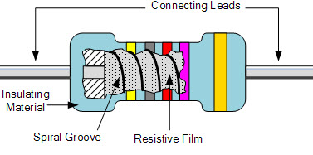

* Thick film and Flimsy film Resistors

These resistors are favored for microwave dynamic and detached power parts, for example, microwave control terminations, microwave control resistors and microwave control attenuators. These are for the most part utilized for applications that require high precision and high solidness.

Normally thick film resistors are made by blending earthenware production in with controlled glass, and these movies having recover capacity extending from 1 to 2%, and a temperature coefficient between + 200 or +250 and - 200 or - 250. These are generally accessible as ease resistors and contrasted and the slender film, thick film resistive component is multiple times thicker.

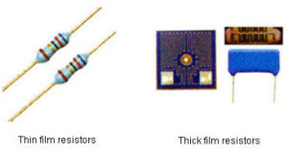

* Surface mount Resistors

Surface mount resistors arrive in an assortment of bundles measure and shape concurred by the EIA (Electronic Industry Union). These are made by saving a film of resistive material and need more space for shading code groups inferable from little size.

The resilience might be as low as 0.02% and comprises of 3 or 4 letters as a sign. The littlest size of the 0201 bundle is a small 0.60mm x 0.30mm resistor and this three number code works along these lines to the shading code groups on wire-finished resistors.

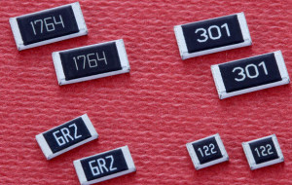

* System resistor

System resistors are a mix of protections that give indistinguishable incentive to all pins. These resistors are accessible in double inline and single inline bundles. System resistors are normally utilized in applications, for example, ADC (Simple to computerized converters) and DAC pull up or pull down.

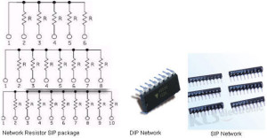

* Variable resistor

Most normally utilized kinds of variable resistors are potentiometers and presets. These resistors comprise of fixed estimation of obstruction between two terminals and are generally utilized for setting the affectability of sensors and voltage division. A wiper (moving some portion of the potentiometer) changes the opposition that can be pivoted with the assistance of a screw driver.

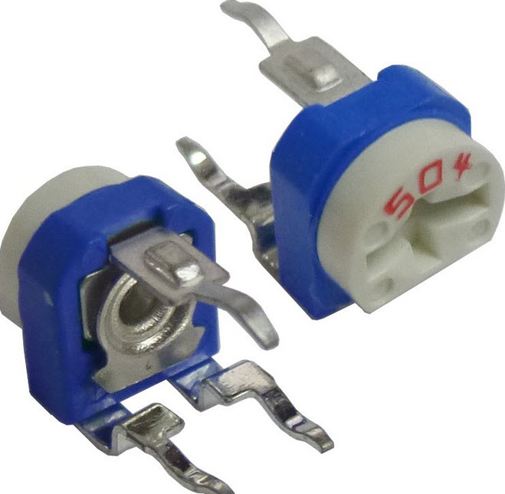

These resistors have three tabs, in which the wiper is the center tab that goes about as a voltage divider, when every one of the tabs are utilized. At the point when the center tab is utilized alongside the other tab, it turns into a rheostat or variable resistor. At the point when just the side tabs are utilized, at that point it acts as a fixed resistor.

* Special Resistors

These are classified into two types:

1.Thermistors

2.Light-Dependent Resistors

Light-dependent Resistors

Light-dependent resistors are very useful in different electronic circuits, especially in clocks, alarms and street lights. When the resistor is in darkness, its resistance is very high (1 Mega Ohm) while in light, the resistance falls down to a few kilo Ohms.

These resistors come in different shapes and colors. Depending on the ambient light, these resistors are used to turn ‘on’ or turn ‘off’ devices.

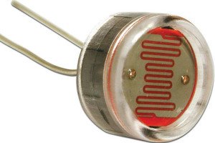

**Resistor Color Code Calculation**

To find out the color code of a resistor, here is a standard mnemonic: B B Roy of Great Britain has a Very Good Wife (BBRGBVGW). This sequence color code helps to find the resistor value by seeing colors on resistors.

Don’t Miss: Best Resistor Color Code Calculator Tool for find out the value of resistors easily.

**Resistor Color Code Calculation:**

* 4 Bands Resistor Color Code Calculation
* In the above 4 bands resistor:

The first digit or band indicates, first significant figure of component.

The second digit indicates, second significant figure of component.

The third digit indicates the decimal multiplier.

The fourth digit indicates tolerance of value in percentage.

To calculate the color code of the above 4 band resistor,

the 4-band resistors consist of colors: yellow, violet, orange, and silver.

Yellow-4, violet-7, orange-3, silver –10% based on BBRGBVGW

The color code value of the above resistor is 47×103 =4.7Kilo Ohms, 10%.

* 5 Bands Resistor Color Code Calculation:

In the above 5 bands resistors, the first three colors indicate significant values, and the fourth and fifth colors indicate multiplying and tolerance values.

* To calculate the color code of the above 5 band resistor, 5 band resistors consist of colors: blue, grey, black, orange, and gold.

Blue- 6, Grey- 8, Black- 0, Orange- 3, Gold- 5%

The color code value of the above resistor is 68×103 = 6.8Kilo Ohms, 5%.

* 6 Bands Resistor Color Code Calculation:

In the above 6 bands resistors, the first three colors indicate significant values; the Fourth color indicates multiplying factor, the fifth color indicates tolerance and the sixth indicates TCR.

* To calculate the color code of the above 6 color-band resistor,

6 band resistors consist of colors: green, blue, black, yellow, gold, and orange.

Green-5, blue-6, Black-0, yellow-4, Orange-3

The color code value of the above resistor is 56×104 =560Kilo Ohms, 5%.

This is all about different resistors and the color-code identification for resistance values. We hope that you might have understood this concept, and therefore, would like you to share your views on this article in the comment section below.

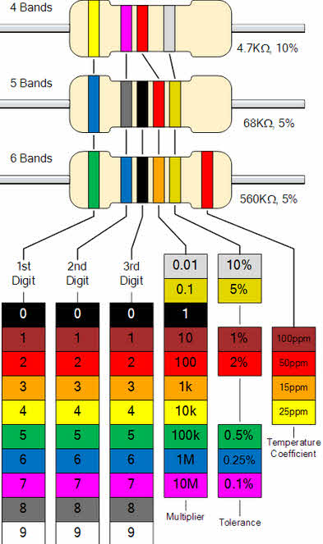

**Uses of Capacitors**:

Capacitors are gadgets which store electrical charge. They are an essential segment of gadgets and have a large group of different applications. The most well-known use for capacitors is vitality stockpiling. Extra utilizes incorporate control molding, signal coupling or decoupling, electronic commotion sifting, and remote detecting. In view of its changed applications, capacitors are utilized in a wide scope of ventures and have become an imperative piece of regular day to day existence.

Capacitors for energy storage:

Capacitors have been utilized to store electrical vitality since the late eighteenth century. Benjamin Franklin was the first to author the adage "battery" for a progression of capacitors in a vitality store application. Singular capacitors by and large don't hold a lot of vitality, giving just enough capacity to electronic gadgets to use during impermanent control blackouts or when they need extra control. For instance, huge capacitors are remembered for vehicle sound frameworks to give additional capacity to speakers when required.

Capacitors for Power conditioning:

One significant utilization of capacitors is the molding of intensity supplies. Capacitors permit air conditioning sign to pass yet square DC signals when they are charged. They can adequately part these two sign sorts, cleaning the inventory of intensity. This impact has been misused to isolate or decouple various pieces of electrical circuits to diminish commotion which could prompt decrease of proficiency. Capacitors are additionally utilized in utility substations to check inductive stacking presented by transmission lines.

Capacitors as Sensors:

Capacitors are utilized as sensors to quantify an assortment of things, including air stickiness, fuel levels and mechanical strain. The capacitance of a gadget is subject to its structure. Changes in the structure can be estimated as a misfortune or addition of capacitance. Two parts of a capacitor are utilized in detecting applications: the separation between the parallel plates and the material between them. The previous is utilized to recognize mechanical changes, for example, increasing speed and weight. Indeed, even moment changes in the material between the plates can be sufficient to adjust the capacitance of the gadget, an impact abused when detecting air dampness.

Capacitors for Signal controlling:

Capacitors have discovered progressively propelled applications in data innovation. Dynamic Irregular Access Memory (Measure) gadgets use capacitors to speak to twofold data as bits. The gadget peruses one worth when the capacitor is charged and another when released. Charge Coupled Gadgets (CCDs) use capacitors in a simple structure. Capacitors are additionally utilized related to inductors to tune circuits to specific frequencies, an impact misused by radio beneficiaries, speakers, and simple equalizers.

**General classifications of power supply –**

**Functional**

These are categorized in various ways ,including with functional features , for example , regulated power supply provides constant out put voltage or current despite variations in load current or input voltage, similarly output of the unregulated voltage changes when there is a change input voltage or load current. Adjustable power supplies allow output voltage or current to be programmed mechanically and controlled mechanically. An isolated power supply has a power output that is electrically independent of its input,this is in contrast to other power supplies that share a common connections between power input and output.

**Packing**

This are classified differently accordingly how they were packed. A bench power supply is a stand alone desktop unit used in applications such as circuits test and development.

Open frame power supplies have only a mechanical enclosure ,sometimes it has only a mounting base, these are typically built into machinery or other equipment.

Rack mount power supplies are designed to be secured into standard electronic equipment racks .An integrated power supply is one that shares a common printed circuit board with its load . An external power supply an external power supply AC adapter or power brick ,is a power supply located in the loads AC power cord that plugs into a wall outlet, a wall wart is an external supply integrated with the outlet plug itself. these are popular in consumer electronics because of their safety.

**Voltage regulator (lc7805):**

|  |  |  |  |
| --- | --- | --- | --- |
| **Pin No.** | **Pin** | **Function** | **Description** |
| 1 | INPUT | Input voltage (7V-35V) | In this pin of the IC positive unregulated voltage is given in regulation. |
| 2 | GROUND | Ground (0V) | In this pin where the ground is given. This pin is neutral for equally the input and output. |
| 3 | OUTPUT | Regulated output; 5V (4.8V-5.2V) | The output of the regulated 5V volt is taken out at this pin of the IC regulator. |

**THANK YOU**